Setup FLUXCD with demo

1)Setup AKS and connect to it
2)Install flux cli
curl -s https://fluxcd.io/install.sh | sudo bash
3)create ns
kubectl create namespace flux-system

4)Install fluxcd on aks cluster for which you need to create dedicated repo and it requires pat token of our account
flux bootstrap github \
--owner=<your-github-username> \
--repository=<your-repository-name> \
--branch=main \
--personal

It will create resources like git repository, kustomization, source controller, helm controller
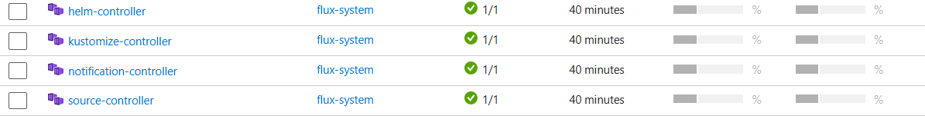
In custom resources it will create git repository and kustomization
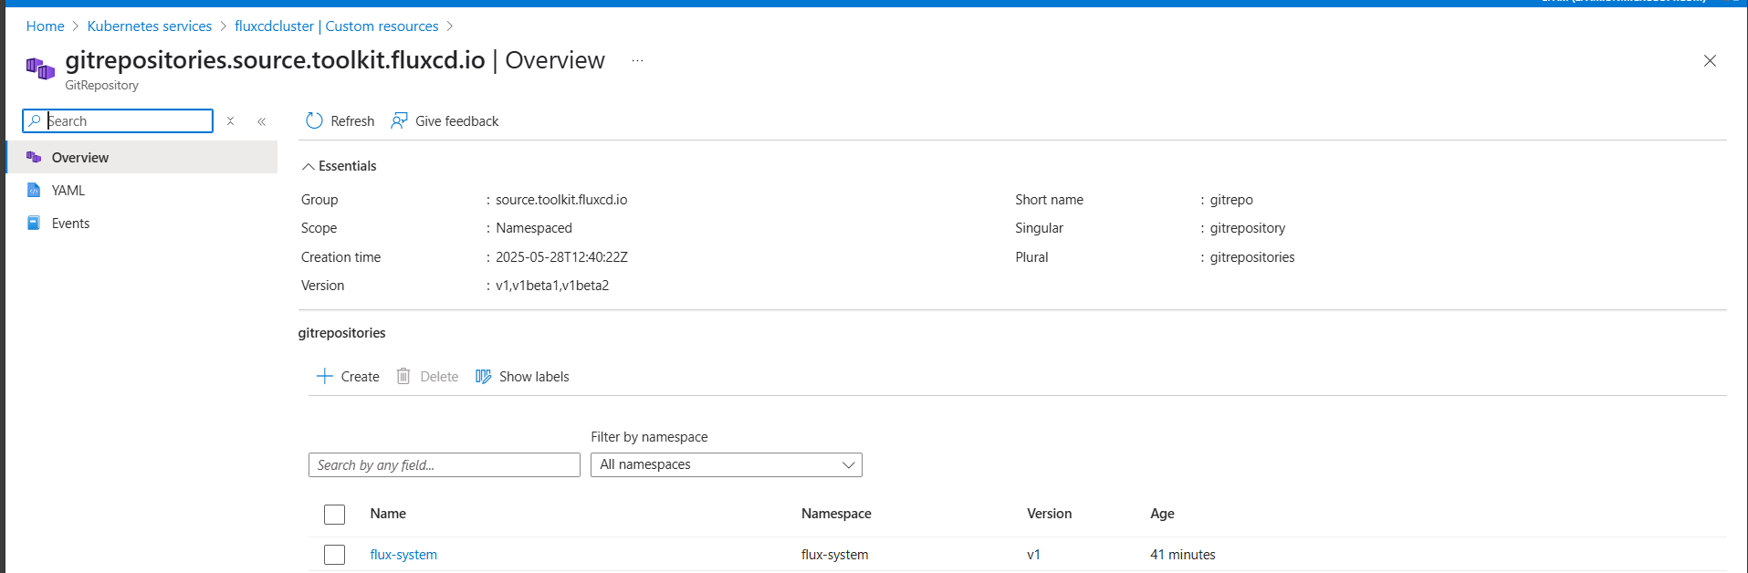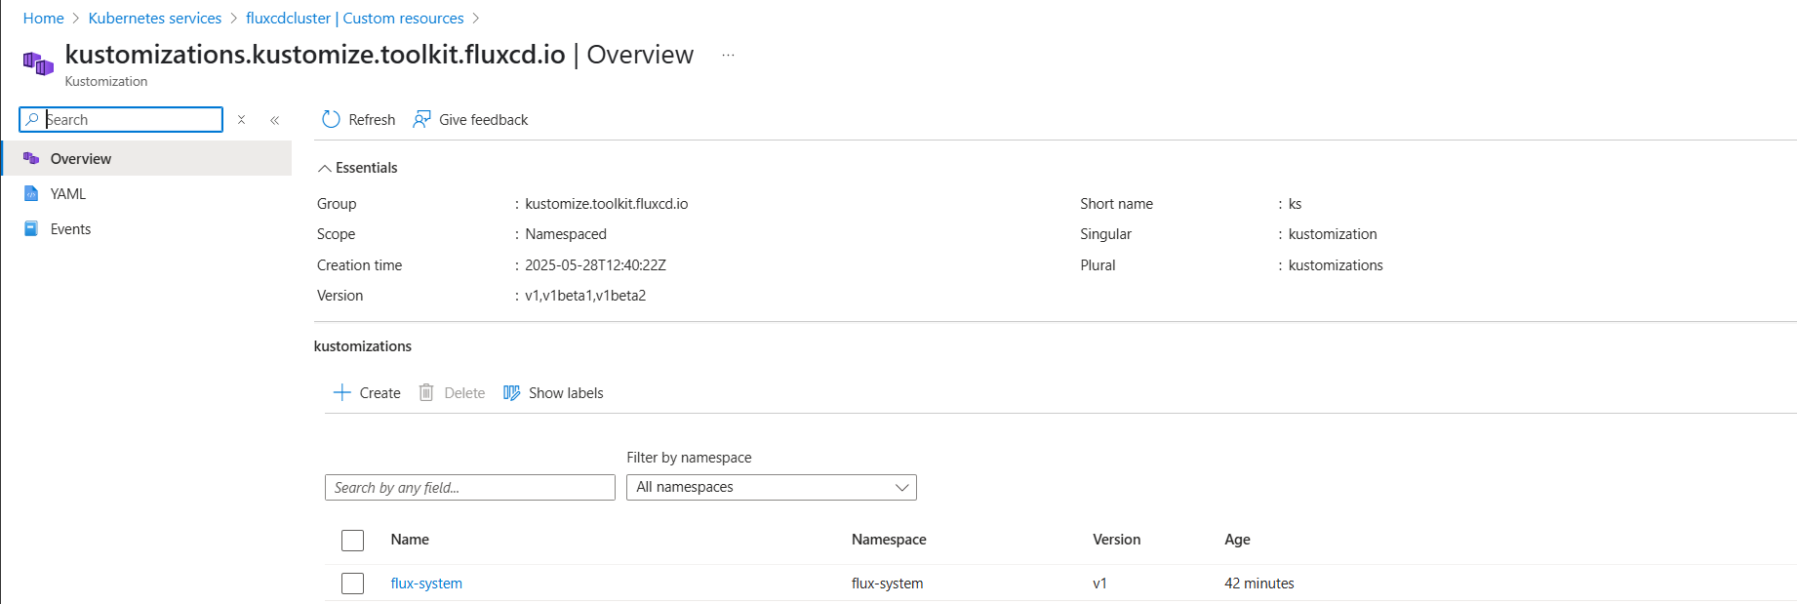

5) now we need to have separate git hub repo for Kubernetes manifest files
Create a directory and keep all manifest files
https://github.com/vaibhavkarade/FLUXCD-DEMO.git

6)create git repository resource in flux
Now, tell Flux to sync the Kubernetes manifests stored in the Git repository to your AKS cluster.
Create a GitRepository custom resource for Flux to track your Git repository. You can apply this resource manually via kubectl.
apiVersion: source.toolkit.fluxcd.io/v1beta1
kind: GitRepository
metadata:
name: flux-demo-repo
namespace: flux-system
spec:
url: https://github.com/<your-github-username>/flux-demo-repo.git
ref:
branch: main
interval: 1m0s

7) Create a Kustomization Resource to Apply Manifests
Flux needs to know how to apply the Kubernetes manifests. We’ll create a Kustomization resource to point to the GitRepository.

# File: flux-system/kustomization.yaml

apiVersion: kustomize.toolkit.fluxcd.io/v1beta1
kind: Kustomization
metadata:
name: flux-demo-app
namespace: flux-system
spec:
interval: 10m
path: "./flux-system"
prune: true
sourceRef:
kind: GitRepository
name: flux-demo-repo
targetNamespace: default

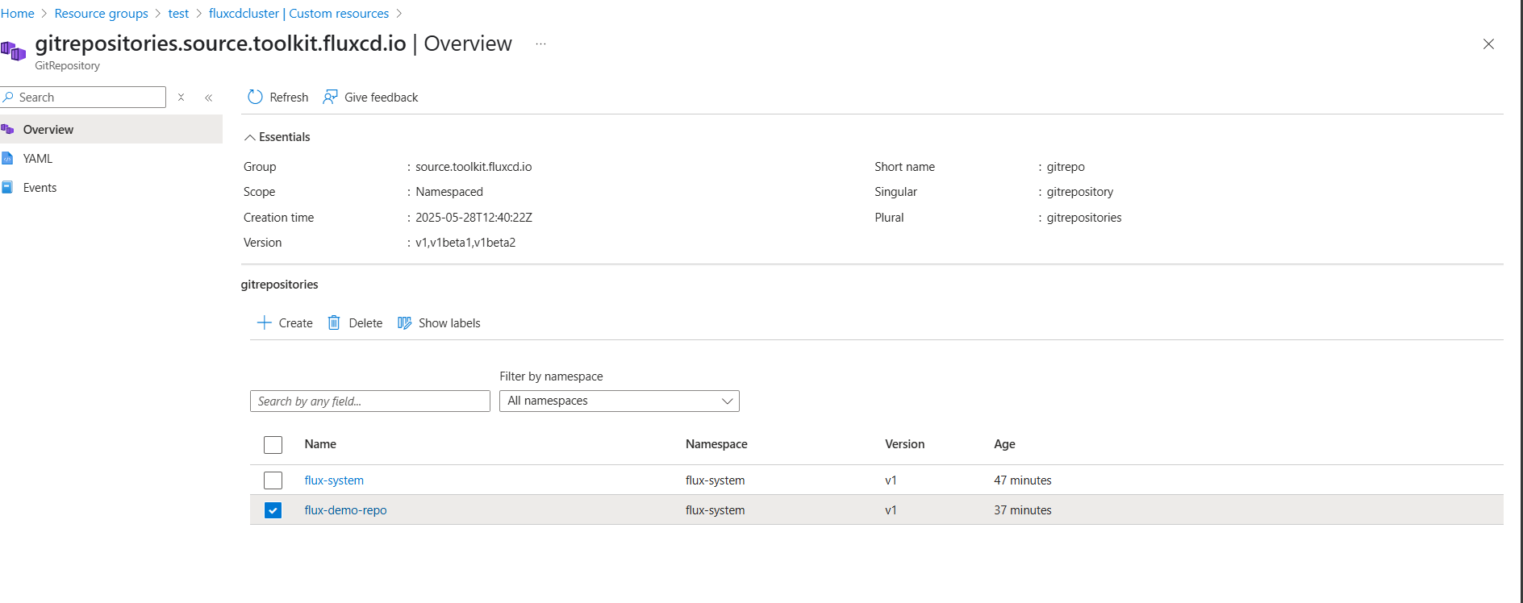

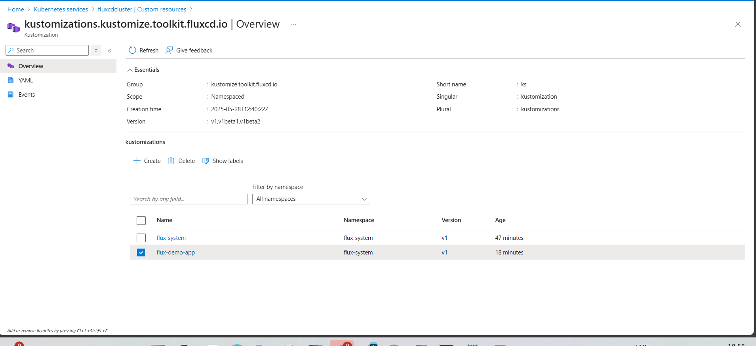

Note: Under source ref name in kustomization should be same as git repository resource name
kind: GitRepository
name: flux-demo-repo
targetNamespace: default

8) After Flux applies the Kubernetes manifests, you can verify the deployment:
kubectl get deployments -n default
kubectl get pods -n default
kubectl get services -n default

9) For testing if we make any changes to manifest repo then fluxcd will detect change as per the specific time and deploy to AKS

